**Content**

* What is Docker
* Need of Docker
* Installing Docker

**Docker**

* Docker is a containerization tool.
* Containerization tool used to package application and dependencies.
* Docker makes code easily deployable across the multiple machines.
* Docker logo is ship carrying components indicated docker makes the code as easily shippable code.

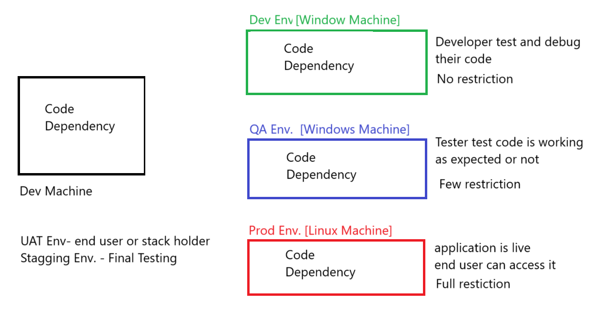

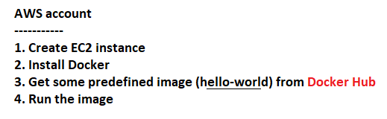

**Create EC2 Instance**

* Name: myec2
* OS: Amazon Linux

**Login to EC2 using MobaXterm**

* Default User Name: ec2-user

